UNIT 1

A VISIT FROM A PEN PAL

Planning date:25/07/2016

Teaching date:29/07/2016

LESSON 2 : SPEAK & LANGUAGE FOCUS 1

A / Aims:- Make & respond to introductions.
- Review the simple past.
B/ Objectives : By the end of the lesson , Ss will be able to practice speaking to introduce oneself and respond its introduction through : Let me introduce myself, pleased to meet you. Do the language focus 1.
C / Teaching aids : Text book , chalk , subordinate board
D / Procedure :

Stages | Time | Activities/ Techniques | Materials
Warm up | 5’ | A.Warm up:  Hoi An  KualaLumpur  Perth  Liverpool  Tokyo  Malaysia  English  Vietnam  Australia  Japan  - T divides Ss into two teams and asks them to choose two numbers.  - Ss turn over the cards and see if they match, ex: Tokyo - Japan. If not, turn the cards face down again and T asks the other team to choose.  - Answer key: Tokyo – Japan  Perth – Australia  Liverpool – English  Hoi An – Vietnam  Kuala Lumpur- Malaysia | Papers, chalks, extraboard  TCs  Group by group
Presentation  Practice  Production | 17’  13’  5’ | II / Pre- speaking :  - Introduce the situation “ Nga and Maryam have not met each other before but they know they will meet each other while waiting for Lan outside her school .  - Ask Ss what they will say if they are Nga or Maryam :  Eg:  S1 : Hello, my name is Nga .What is your name ?  S2: Hello, my name is Nga . Are you Maryam ?  S3 : Hi , I am Nga . What is your name ?  Ss: Listen carefully; Practice in group of 3 Ss; Copy down .  - Correct the mistakes and give suggested answers :  - Ask them to repeat and write  - Have Ss read the dialogue and put their dialogue in the correct order .  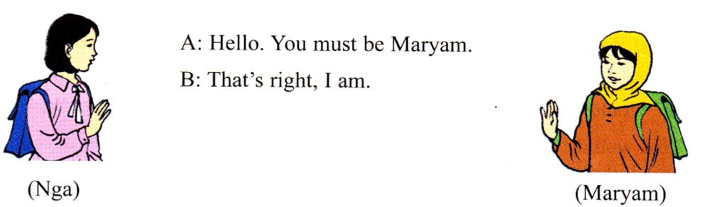  * Note : You must be Maryam  - Call on some pairs to read the complete dialogue .  Ss:  - Work in pairs  - Practice in front of class.  - Repeat and copy down .  Correct mistakes and ask some pairs to demonstrate before class. Then Give the right answers :  1- c 4 - d 3 - a 5 - b 2 - e 6 - f  III / While - Speaking :  - Introduce the aims of the exercise b  - Give examples for them to understand more  - Ask Ss to work in pairs .  - Call on some pairs to practice  - Remark and correct if any .  Ss: listen and practice in pairs and some pairs do it in front of class. T checks spelling and pronunciation.  IV / Post - speaking :  Review the past simple tense : LF 1/11  - Ask Ss to look at the dialogue in the book and guide  “ These above are dialogues between two Ss talking about things Ba did last week “ and tell them to work in pairs , study the table and make similar dialogue about Nga , Lan, Hoa,s weekend .  - Call on some pairs to read the dialogues aloud .  - Some pairs speak aloud in front of the class.  - Teacher listens and corrects the mistakes  - Remark and correct the mistakes . Then give correct answers :  Nga  A : What did Nga do on the weekend ?  B : She went to a concert performed by Ha Noi singers  A : When did she go to see it ?  B : She saw it on Saturday evening at 8 pm . | Pictures,  Extra board.  Tcs  SB  Pairwork  Some pairs go to the bb to practise  Pairwork  Picture of sentences  Paper of past simple tense (form)
 | 3’ | IV / Consolidation :  Ask Ss to give the form of the simple past tense.  They say aloud & T writes them on board. | Individually
Homework | 2’ | V /  1. Learn by heart the models .  2. Copy down the complete dialogue .  3. Write about the three friend of Maryam .  4. Prepare the section: listen and LF 2,3  * Feedback : | Remember them and note down

THE END

