Week: 05
Period: 13

UNIT 2: CITY LIFE
Lesson 6: Skills 2

I. OBJECTIVES
By the end of this lesson, Ss will be able to:
1. Knowledge
- Listen for specific information in an interview about life in the city;
- Write a paragraph on what they like or dislike about city life.
2. Competences
- Develop communication skills and creativity;
- Be collaborative and supportive in pair work and teamwork.
3. Personal qualities
- Be encouraged to express opinion about city life;
- Actively join in class activities.
II. MATERIALS
- Grade 9 textbook, Unit 2, Skills 2
- Computer connected to the Internet
- Projector / TV
- hoclieu.vn
Assumption
Anticipated difficulties | Solutions
Ss may have underdeveloped listening skills. | - Play the recording many times if necessary.  - Encourage Ss to work in pairs, in groups so that they can help each other.  - Provide feedback and help if necessary.
Some Ss will excessively talk in the class. | - Define expectations in explicit detail.  - Have excessively talkative Ss practise.  - Continue to define expectations in small chunks (before every activity).
III. PROCEDURES
1. WARM-UP (5 mins)
a. Objectives:
- To create an active atmosphere in the class before the lesson;
- To lead into the new lesson.
b. Content:
- Think!
- Game: Pass the ball
c. Expected outcomes:
- Ss can answer the questions related to school.
d. Organisation:
TEACHER’S ACTIVITIES | STUDENTS’ ACTIVITIES | CONTENTS
Option 1: Think!  - Show photos or a video of a modern and beautiful city. Ask Ss if they like that city and why.  - Lead to the new lesson: Listening and Writing lesson on advantages and disadvantages of city life.  - Introduce the objectives of the lesson. Write the objectives in the left corner of the board. | - Look and show ideas. | Pictures:  
Option 2: Pass the ball  - Give two balls to two different Ss.  - When the music starts, Ss pass the balls to Ss next to them.  - When the music stops, the two Ss have a ball must stand up to tell about beautiful city that they want to live in. | - Listen and play games. | Questions:  - Which city do you want to live in? Why?
e. Assessment:
- T corrects Ss (if needed).
2. ACTIVITY 1: LISTENING (20 mins)
a. Objectives:
- To help Ss develop their skill of listening for specific information about city life.
b. Content:
- Task 1: Work in pairs. Tick (√) the things that you want in your hometown. Add more ideas if you have any.
- Task 2: Listen to an interview with three teenagers about life in their cities. Decide if the statements are true (T) or false (F).
- Task 3: Listen again. Choose the correct answer A, B, or C.
c. Expected outcomes:
- Ss can listen for general and specific information to do the learning tasks.
d. Organisation:
TEACHER’S ACTIVITIES | STUDENTS’ ACTIVITIES | CONTENTS
Task 1: Work in pairs. Tick (√) the things that you want in your home town. Add more ideas if you have any.
- Tell Ss to look at the given phrases and ask them to tick the things they want in a city.  - Invite answers from Ss.  - Tell Ss that these phrases will appear in the listening, so they should pay attention to them. | - Listen and follow. | Suggested answers:  Ss’ own answers.
Task 2: Listen to an interview with three teenagers about life in their cities. Decide if the statements are true (T) or false (F).
- Tell Ss that they are going to listen to three teenagers talking about what they like and dislike about their city.  - Have Ss look at the statements. Elicit from them the keywords in each statement. Remind them that they need to listen attentively.  - Play the recording and ask Ss to listen and decide if the information is true or false according to the recording.  - Ask one or two Ss to go to the board and write their answers. Have other Ss work in pairs to compare their answers.  - Confirm the correct answers. Play part of the recording again when needed. | - Listen to the instruction.  - Find keywords.  - Listen and do the exercise.  - Check answers in pairs.  - Show the answers.  - Listen and check answers. | Answer key:  1. T  2. F  3. F  4. T
Task 3: Listen again. Choose the correct answer A, B, or C.
- Tell Ss that they are going to listen to the speakers again and choose the correct answer.  - Have Ss read the questions and underline the keywords in each question. Elicit from Ss that Question 1 helps practise listening for gist.  - Play the recording and ask Ss to listen again and choose the correct answer. Then Ss work in pairs to compare their answers with each other.  - Check the answers to 3 with the whole class. Ask Ss to explain their choices. Confirm the correct answers.  Transition from Listening to Writing  - Ask Ss to work in pairs and recall information about Tom, Elena and Chi. Note down the answers to the questions.  + What does each person like about life in their city?  + What does each person dislike about life in their city? | - Listen to the instruction.  - Find keywords.  - Listen and do the exercise.  - Check answers in pairs.  - Listen and check answers.  - Work in pairs. Note down the answers. | Answer key:  1. A 2. A 3. B 4. C  Suggested answers:  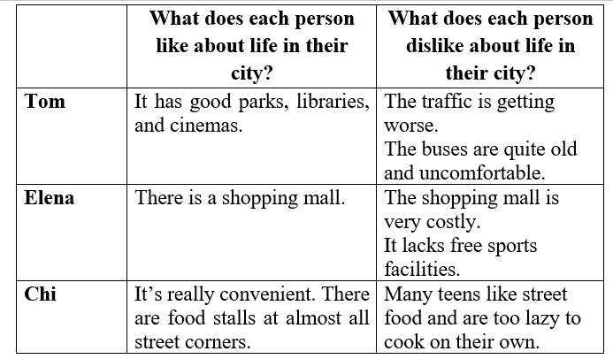
e. Assessment:
- T checks Ss’ answers as a whole class.
3. ACTIVITY 2: WRITING (18 mins)
a. Objectives:
- To help Ss practise writing a paragraph about what they like or dislike about living in a city.
b. Content:
- Task 4: Work in pairs. Put the phrases from the box in the correct column.
- Task 5: Write a paragraph (about 100 words) about what you like or dislike about living in a city. You can use the ideas in 4 or your own ideas.
c. Expected outcomes:
- Ss can use learned vocabulary and grammar to write a paragraph about what they like or dislike about living in a city.
d. Organisation:
TEACHER’S ACTIVITIES | STUDENTS’ ACTIVITIES | CONTENTS
Task 4: Work in pairs. Put the phrases from the box in the correct column.
- Have Ss work in pairs to put the phrases in the correct column.  - Have some Ss present their answers or write their answers on the board. Confirm the correct answers. | - Work in pairs to do the exercise.  - Present their answers. | Answer key:  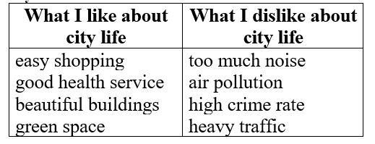
Task 5: Write a paragraph (about 100 words) about what you like or dislike about living in a city. You can use the ideas in 4 or your own ideas.
- Tell Ss to look at the outline in  - Tell them that they should follow this structure when writing this paragraph.  - Ask Ss to write their paragraph individually based on the table in  Remind them that they do not need to use all suggested ideas, and that they can add their | - Listen.  - Write a paragraph by using table in 4. | Sample paragraph:  I love city life. First, it is very convenient to live in the city. The public transport system reaches almost all areas of the city, so it is easy for me to get around. In addition, there are many shops that sell all
own ideas.  - When Ss have finished, if time permits, check one writing in class. Otherwise, collect some writings to correct at home. |  | kinds of goods, so I can buy almost everything I need. Second, the city often has many good schools and hospitals. Therefore, people here can enjoy quality education and healthcare. Finally, city life is exciting. There are many entertainment places for me and my friends.

e. Assessment:
- T gives corrections and feedback.
4. CONSOLIDATION (2 mins)
a. Wrap-up
- Summarise the main points of the lesson.
b. Homework
- Rewrite the paragraph in the notebooks.
- Do exercises in the workbook.

* Evaluation: ……………………………………………………………………………………………………
……………………………………………………………………………………………………
……………………………………………………………………………………………………
……………………………………………………………………………………………………
……………………………………………………………………………………………………
……………………………………………………………………………………………………
……………………………………………………………………………………………………
……………………………………………………………………………………………………
……………………………………………………………………………………………………
……………………………………………………………………………………………………
……………………………………………………………………………………………………
……………………………………………………………………………………………………
……………………………………………………………………………………………………

