Week: 05
Period: 15

UNIT 3: COMMUNITY SERVICE
Lesson 1: Getting started

I. OBJECTIVES: By the end of this lesson, Ss will be able to gain:
1. Knowledge
- An overview about the topic “Community service”;
- Use lexical items related to community activities.
2. Core competence
- Develop communication skills and enhance awareness of preserving the culture
- Be collaborative and supportive in pair work and teamwork
- Actively join in class activities
3. Personal qualities
- Develop self-study skills
- Raise students’ awareness of the need to keep their neighbourhood green
II. MATERIALS
1. Teacher: - Grade 7 textbook, planning (Unit 3: Getting started )
- Smart TV/ Pictures, sets of word cards
2. Students: Text books, notebooks, posters,…
3. Method: Ask and answer; group works; individual,…
III. PROCEDURES: (STAGES)
ACTIVITY 1: WARM-UP (5’)
* Aim: To introduce the new lesson.
* Content: Guess the word.
* Outcome: Students understand and say activities about “Community service”.
* Organization of implementation:
Teacher’s and Students’ activities | Content
* Warm-up: T-Ss  - T shows the picture and definition for Ss to guess the word.  - Ss raise hands to answer the questions.  - T asks Ss to say out the words.  Lead in:  “Do you ever think of helping the community? Should we try to do good things for people around us? Let’s find more in our lesson today. | * Guess the word:  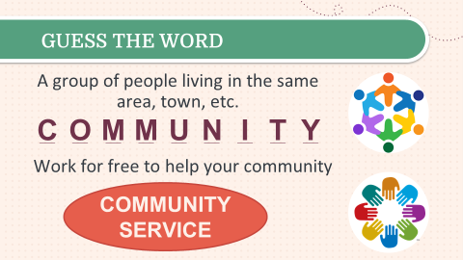  Community service
ACTIVITY 2: PRESENTATION (8’)
Pre teach vocabulary
* Aim: - To provide students with vocabulary.
- To help students well-prepared for the listening and reading tasks.
* Content: Learn some vocabularies related to the topic.
* Outcome: Students read and understand the meaning of vocabulary.
* Organization of implementation:
Teacher’s and Students’ activities | Content
* Pre-teach vocabulary  - T uses different techniques to teach vocabulary (pictures, explanation…)  - Follow the seven steps of teaching vocabulary.  - T invites some Ss to go to the board and mark the stress on the words.  - Repeat in chorus and individually. | * Vocabulary  - community activity /kəˈmjuːnɪti ækˈtɪvəti/ (n.phr.): hoạt động cộng đồng  - donate /dəʊˈneɪt/ (v): quyên góp, ủng hộ  - nursing home /ˈnɜːsɪŋ həʊm/ (n.phr.): viện dưỡng lão  - homeless /ˈhəʊmləs/ (adj): vô gia cư
ACTIVITY 3: PRACTICE (20’)
Task 1
* Aims: - To set the context for the introductory conversation.
- To introduce the topic of the unit.
* Content: Listen and read the conversation.
* Outcome: - Students read and understand the meaning of the conversation.
- Students know how to role play.
* Organization of implementation:
Teacher’s and Students’ activities | Content
* Set the context: T-Ss  - T draws Ss’ attention to the picture in the textbook and asks them about “community activities”.  - Encourage Ss to answer, but do not confirm whether their answers are right.  - Then, T plays the recording to check the answer with the whole class.  - T lets Ss to practise the conversation with the partners in 3 minutes.  - T invites some pairs of Ss to read aloud.  - T checks Ss’ pronunciation and gives feedback. | * Questions:  - What can you see in the pictures?  - What do you think the boys and the girls are doing?  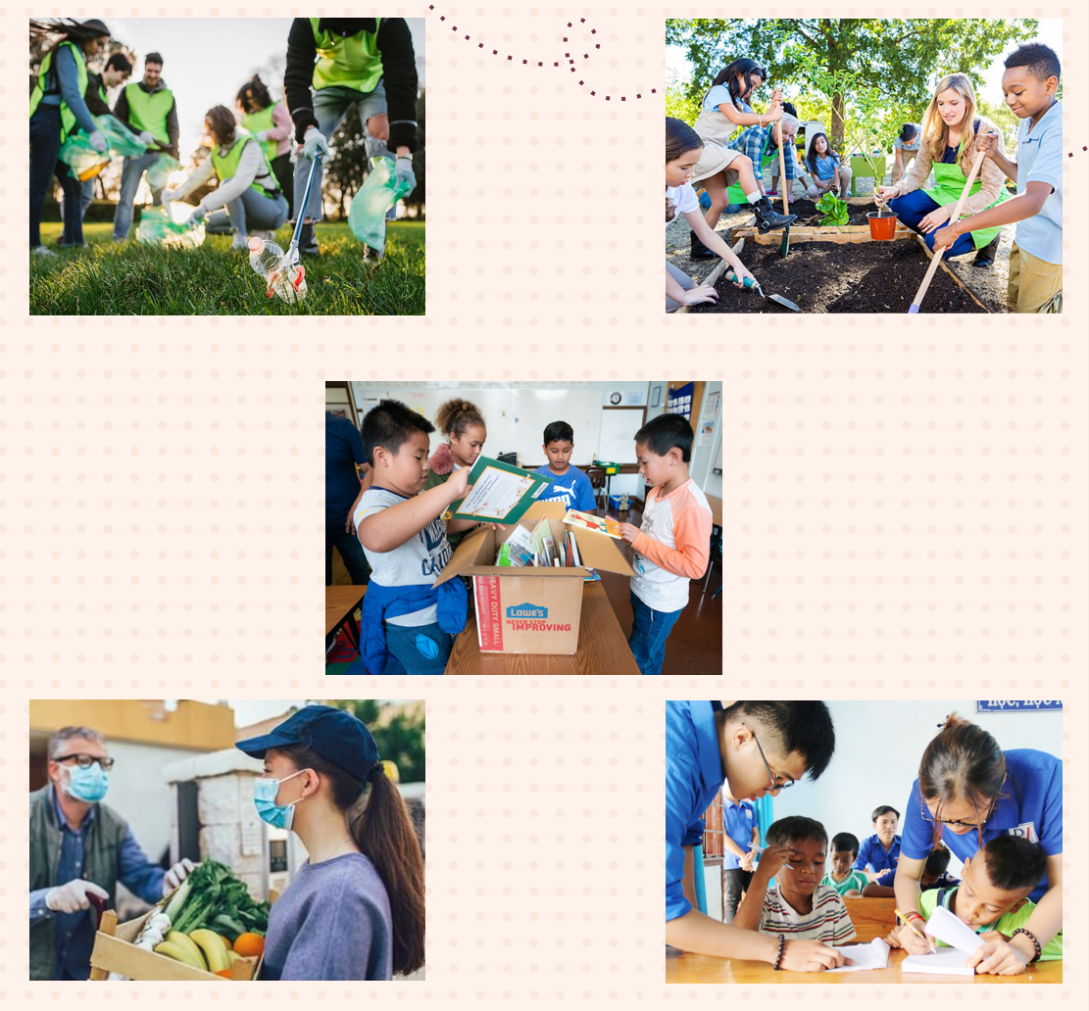  * Suggested answers:  + picking up litter  + planting vegetables  + donating books  + donating vegetables  + teaching English  Task 1: Listen and read.
Task 2
* Aim: To help students read for specific information about Minh and Tom’s community activities.
* Content: Read the conversation again and tick the appropriate box.
* Outcome: Students tick the appropriate boxes. Some pairs say the answers aloud.
* Organization of implementation:
Teacher’s and Students’ activities | Content
Task 2: T-Ss, Ss-Ss, T-Ss  - T tells Ss to read the conversation again and work individually to find the answers.  - Ss can underline the words and phrases about community activities then work together for one or two minutes to check the words/ phrases they have underlined.  - Have pairs tick the appropriate boxes. Ask pairs to say the answers aloud: Mith's club picks up litter; Tom's club donates books, etc.  - Make sure they pronounce the words/ phrases correctly.  - Check the answers as a class. | Task 2: Read the conversation again and tick the appropriate box.  * Answer key:  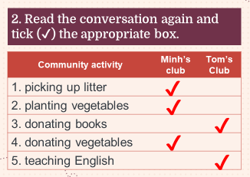
Task 3
* Aims: - To help students use phrases related to community activities.
- To help students further understand the text.
* Content: Complete the phrases under the pictures with the verbs below.
* Outcome: Students say the phrases aloud and pronounce the words and phrases correctly.
* Organization of implementation:
Teacher’s and Students’ activities | Content
Task 3: T-Ss, Ss-Ss  - T asks Ss to work individually to complete the phrases under the pictures with the given verbs.  - Ss work individually to complete the task.  - T allows Ss to share answers before discussing as a class.  - T asks Ss to say the phrases aloud and makes sure they pronounce the words and phrases correctly. T can ask for translation to check their understanding. | Task 3: Complete the phrases under the pictures with the verbs below.  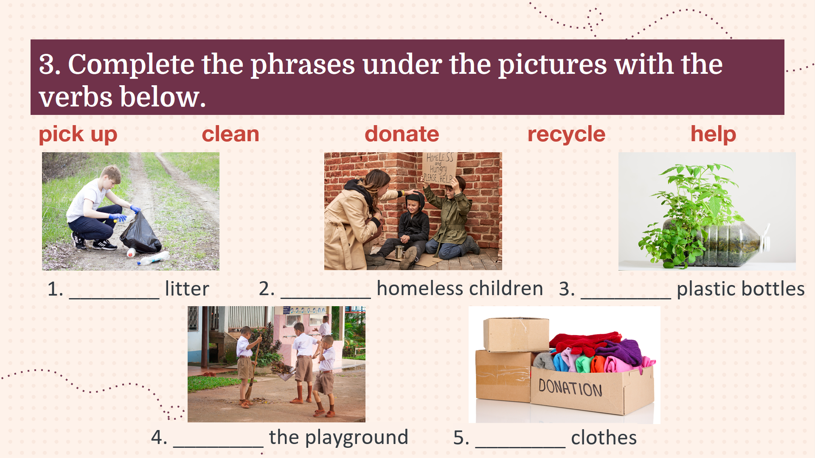  * Answer key:  1. pick up  2. help  3. recycle  4. donate  5. clean
ACTIVITY 4: PRODUCTION (8’)
Task 4
* Aim: To help students use the vocabulary related to community activities in the right contexts.
* Content: Complete the sentences with the correct words or phrases below.
* Outcome: Students read aloud the full sentences.
* Organization of implementation:
Teacher’s and Students’ activities | Content
Task 4: T-Ss, Ss-Ss  - T asks Ss to find out the key word in each sentence. Then, Ss fill in the blanks with the most suitable words/ phrases.  - T allows Ss to share answers before discussing as a class.  - T asks Ss to read aloud the full sentences and correct their pronunciation if needed. T can ask for translation to check their understanding. | Task 4: Complete the sentences with the correct words or phrases below.  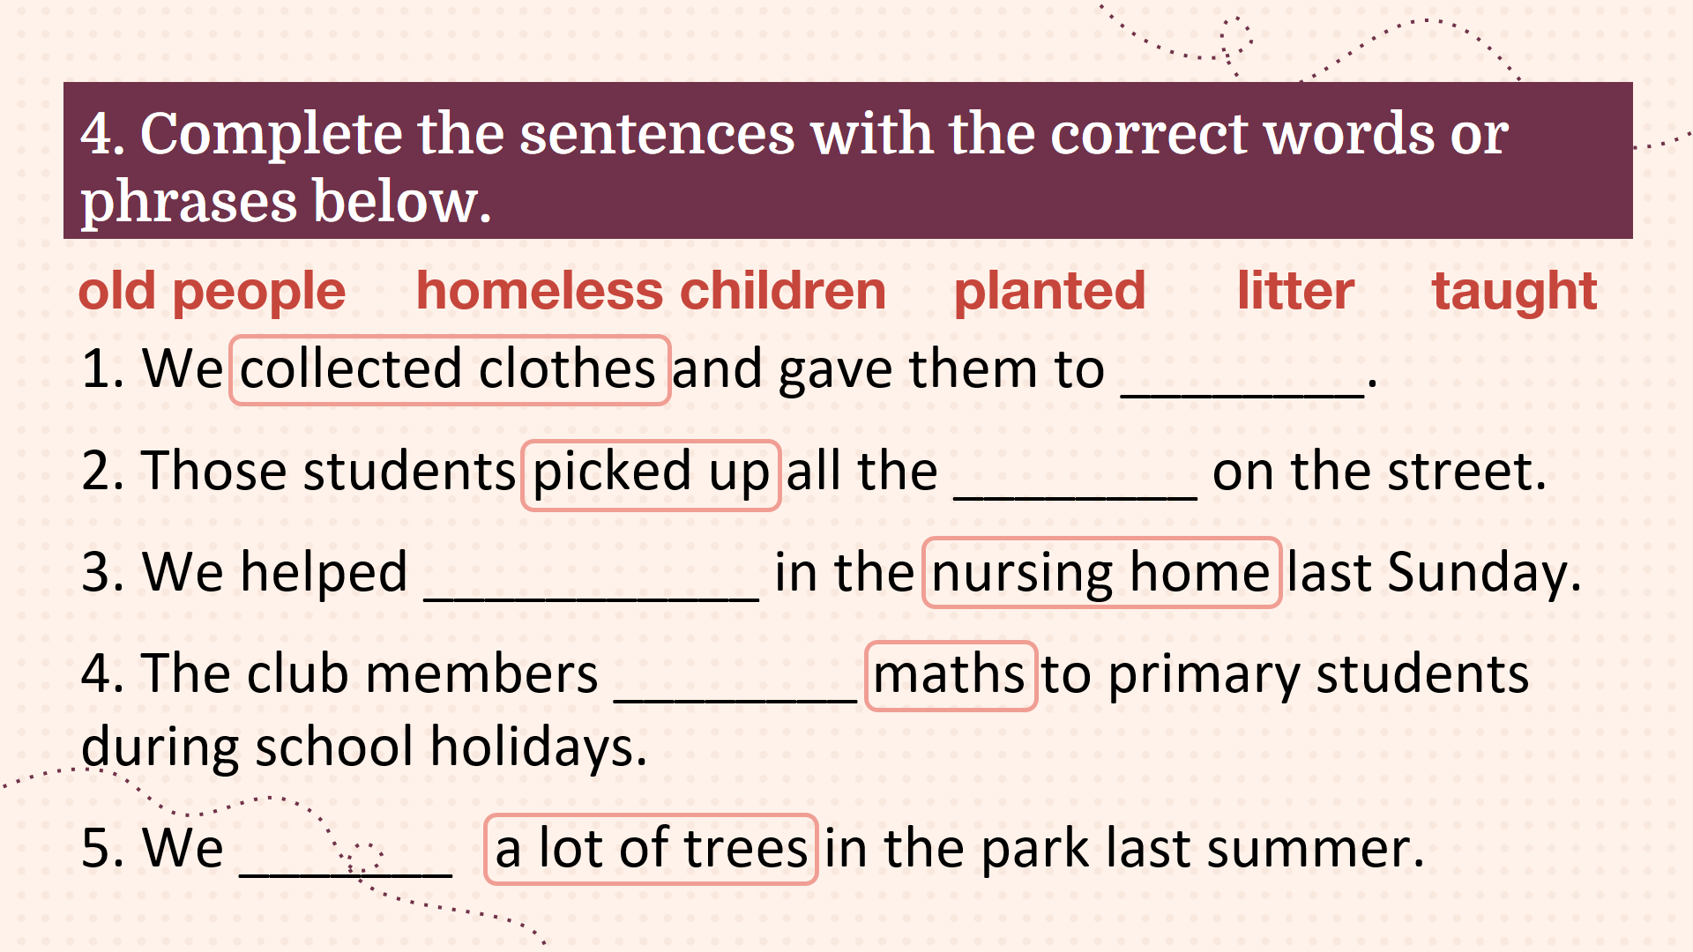  * Answer key:  1. homeless children  2. litter  3. old people  4. taught  5. planted
ACTIVITY 5: CONSOLIDATION (6’)
* Aims: - To help students review what they have learnt.
- To create a fun atmosphere in the class.
* Content: Recap the content of the lesson.
* Outcome: Students choose the correct answers.
* Organization of implementation:
Teacher’s and Students’ activities | Content
- T shows 2 questions on the screen to consolidate what Ss have learnt in the lesson.  - Ss choose the correct answers. | 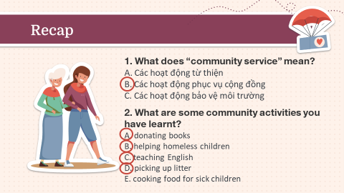
HOMEWORK (3’)
* Aim: To review the lesson and prepare for the next lesson.
* Content: Review the lesson and prepare for the next lesson (A closer look 1).
* Outcome: Students’ textbook and workbook.
* Organization of implementation:
Teacher’s and Students’ activities | Content
- T reminds Ss to do homework and prepare the new lesson. | - Learn by heart all the new words.  - Practise reading the conversation again.  - Prepare: Unit 3 - Lesson 2.

EVALUATION: ………………………………………………………………………………………………………
………………………………………………………………………………………………………………………………………………………………………………………………………………

